Introduction to Web Applications & Architecture

1. What is a Web Application?
A web application is a software system accessed via a web browser over a network (usually the Internet) that performs dynamic operations, processes user input, interacts with databases, and returns customized responses.

Key Characteristics
- Runs on a client–server model
- Uses HTTP/HTTPS as communication protocol
- Supports dynamic content generation
- Often handles authentication, sessions, and data storage

Examples
- Online banking portals
- E-commerce websites
- Learning Management Systems (LMS)
- Cloud dashboards (AWS Console, Azure Portal)

2. Difference Between Website and Web Application
Feature | Website | Web Application
Nature | Informational | Interactive
User Input | Minimal | Extensive
Backend Processing | Limited | Heavy
Database | Optional | Mandatory
Security Risks | Lower | High
Example | Blog, News Site | Banking App, E-commerce

3. Basic Web Application Architecture (3-Tier Model)

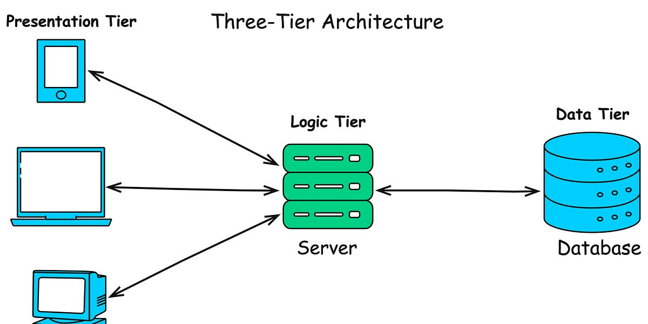
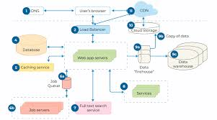

Tier 1: Client (Presentation Layer)
- Runs on user’s browser
- Technologies:
  - HTML (structure)
  - CSS (styling)
  - JavaScript (logic)
- Sends HTTP requests and receives responses
📌 Security relevance:
XSS, CSRF, clickjacking, client-side validation bypass

Tier 2: Application Server (Business Logic Layer)
- Processes client requests
- Enforces authentication & authorization
- Applies business rules
- Communicates with database
Common technologies:
- PHP, Java, Python, Node.js
- Frameworks: Spring, Django, Express, Laravel
📌 Security relevance:
SQL Injection, Broken Authentication, SSRF, RCE

Tier 3: Database Server (Data Layer)
- Stores:
  - User credentials
  - Application data
  - Logs and transactions
- Examples:
  - MySQL, PostgreSQL
  - MongoDB (NoSQL)
📌 Security relevance:
Data leakage, SQL/NoSQL Injection, privilege escalation

4. Detailed Request–Response Flow

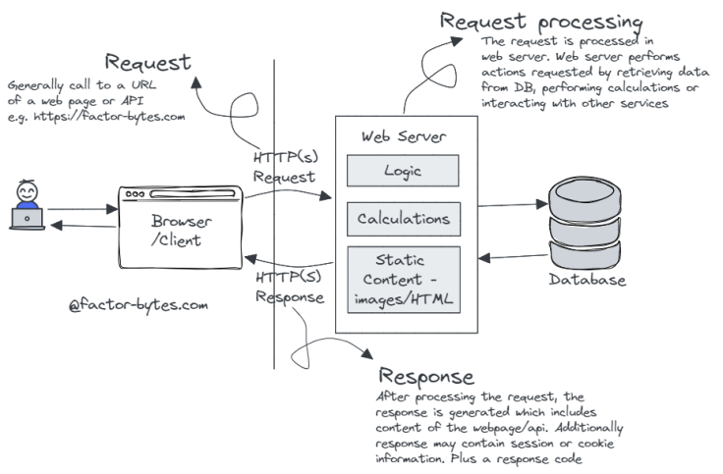
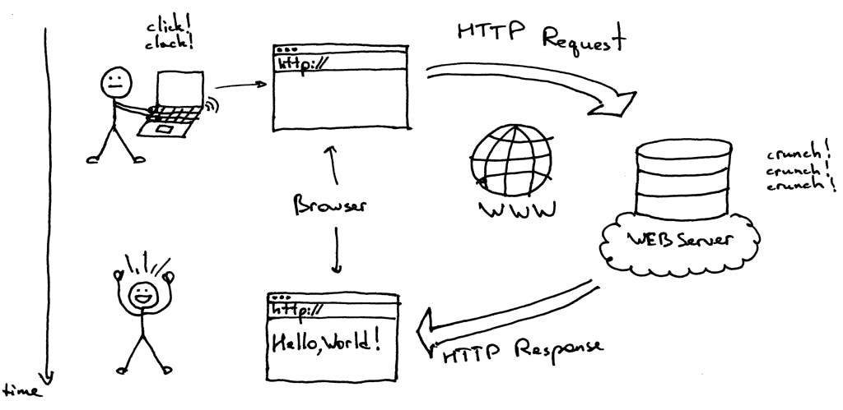

Step-by-Step Flow
- User enters URL in browser
- Browser sends HTTP request
- Web server forwards request to application logic
- Application queries database (if required)
- Server generates response (HTML/JSON)
- Browser renders output

5. Core Components of Web Application Architecture

5.1 Web Server
Handles incoming HTTP requests.
Examples:
- Apache
- Nginx
- IIS
Functions:
- Routing requests
- Serving static content
- Forwarding dynamic requests

5.2 Application Logic
- Implements rules and workflows
- Handles:
  - Login validation
  - Form processing
  - Role-based access control

5.3 Database
Stores persistent data.
Types:
- Relational (SQL)
- Non-relational (NoSQL)

5.4 Session Management
- Maintains user state
- Uses:
  - Cookies
  - Session IDs
  - Tokens (JWT)
📌 Security relevance:
Session hijacking, fixation, replay attacks

6. Authentication vs Authorization
Authentication | Authorization
Who are you? | What can you do?
Login process | Access control
Username/password | Roles & permissions

7. Types of Web Application Architectures

7.1 Monolithic Architecture
- All components in one codebase
- Simple but hard to scale
📌 Security risk:
Single vulnerability → full compromise

7.2 Microservices Architecture
- Application split into services
- Each service runs independently
📌 Security risk:
API abuse, service-to-service attacks

7.3 Serverless Architecture
- Backend logic runs as functions
- Example: AWS Lambda
📌 Security risk:
Misconfigured permissions, event injection

8. Common Web Application Attack Surface
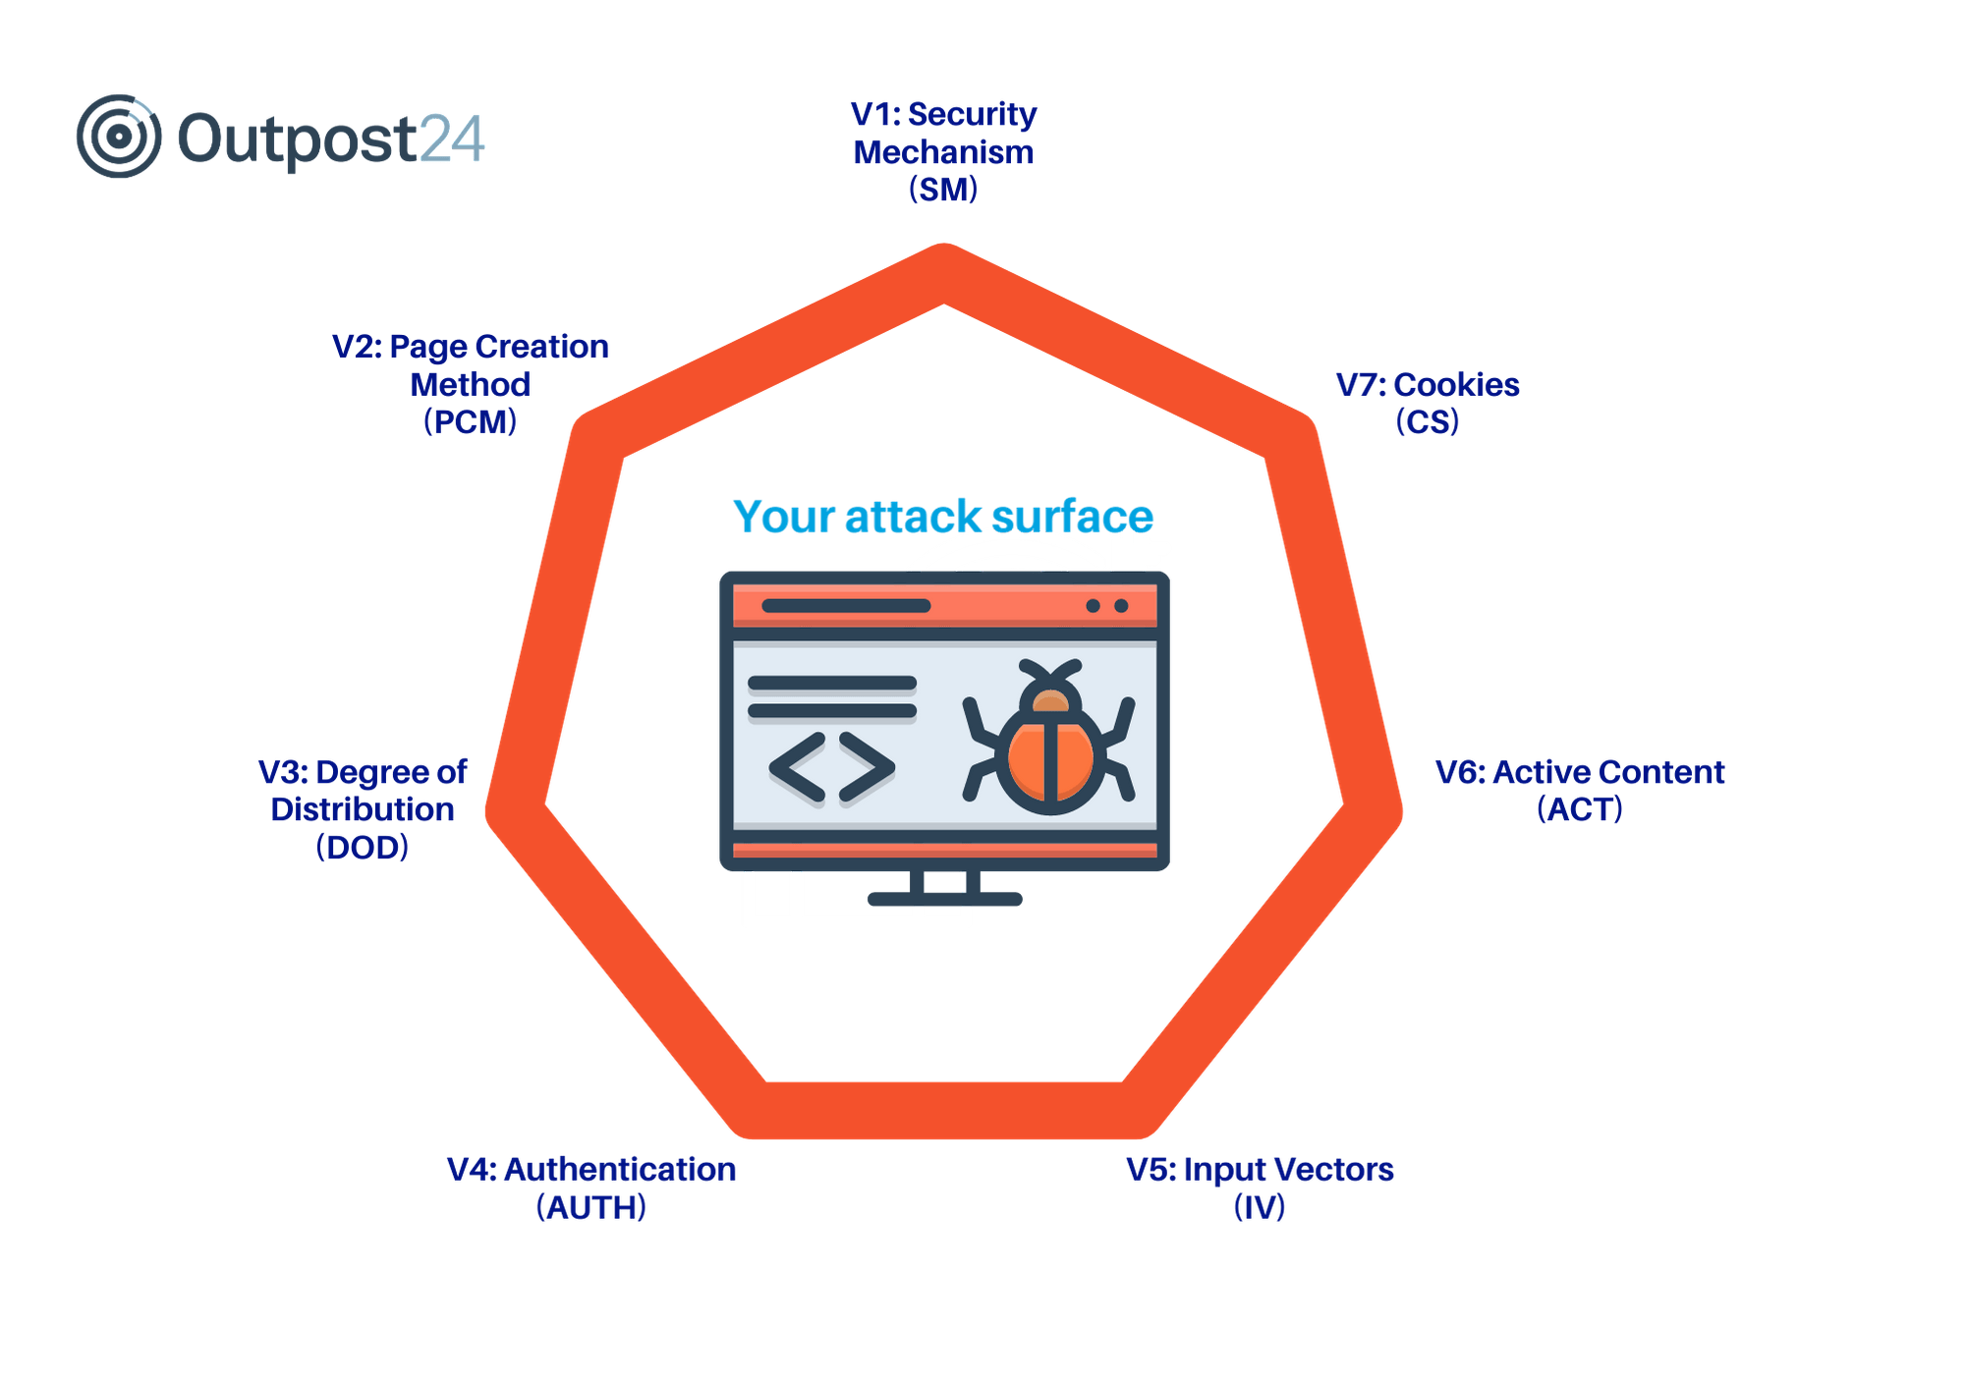
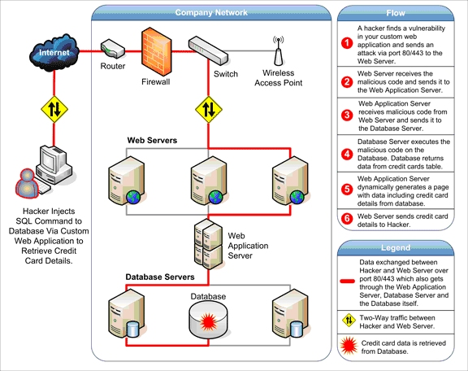
Layer | Common Attacks
Client | XSS, CSRF
Server | SQLi, RCE
Database | Data leakage
Network | MITM
Authentication | Brute force

9. Why Web Applications are High-Risk Targets
- Internet-facing
- Handle sensitive data
- Complex codebases
- Frequent third-party dependencies
- Poor input validation

10. Security by Design – Key Takeaways
✔ Validate input at server side
✔ Use prepared statements
✔ Secure session management
✔ Enforce least privilege
✔ Apply HTTPS everywhere

